A FITNESS GUIDE CHATBOT

# A PROJECT REPORT

***Submitted by***

# SHAKTHI PRIYA V

# (220701259)

***in partial fulfillment for the course***

## OAI1903 - INTRODUCTION TO ROBOTIC PROCESS AUTOMATION

***for the degree of***

# BACHELOR OF ENGINEERING

***in***

**COMPUTER SCIENCE ENGINEERING**

# 

# RAJALAKSHMI ENGINEERING COLLEGE

# 

# RAJALAKSHMI NAGAR,

# THANDALAM,CHENNAI – 602 105

**NOVEMBER 2024**

# RAJALAKSHMI ENGINEERING COLLEGE CHENNAI - 602105

BONAFIDE CERTIFICATE

Certified that this project report **“A Fitness Guide Chat Bot”** is the bonafide work of **“V Shakthi Priya (220701259)”** who carried out the project work for the subject OAI1903 - Introduction to Robotic Process Automation under my supervision.

|  |
| --- |
| **Dr.N.DuraiMurugan,**  **M.E.,ph.D**  **SUPERVISOR**  Professor  Department of  Computer Science and Engineering  Rajalakshmi Engineering College  Rajalakshmi Nagar  Thandalam  Chennai - 602105 |

Submitted to Project and Viva Voce Examination for the subject OAI1903 - Introduction to Robotic Process Automation held on .

**Internal Examiner External Examiner**

# ABSTRACT

"The Fitness Guide Chat Bot" is an innovative and personalized health management tool developed using Robotic Process Automation (RPA) principles. This intelligent bot assists users in achieving their fitness goals, whether they aim to lose or gain weight, by providing tailored diet and exercise plans. Upon user interaction, the bot prompts for input of height and weight, then analyzes this data to recommend a customized plan that aligns with the user’s desired health outcomes. Additionally, the bot offers the convenience of sending the comprehensive diet and exercise plan directly to the user's email, ensuring easy access and continuous motivation. By automating the process of diet and workout customization, "The Fitness Guide Chat Bot" reduces the complexity and manual effort involved in creating effective fitness routines, making health and wellness management seamless and efficient. This project demonstrates the capability of RPA in promoting healthier lifestyles through technology-driven solutions. The integration of Chatgpt for content generation ensures that each diet and exercise plan is both current and enriched with expert knowledge, adding depth and variety to the user experience. The bot is adaptive nature allows it to cater to a wide range of user preferences and dietary restrictions, making it highly inclusive. Furthermore, the use of AI-driven analysis helps maintain a high level of precision in plan recommendations, enhancing their effectiveness and user satisfaction. The chatbot seamless communication interface fosters user engagement, making the interaction intuitive and approachable for people of all fitness levels.

**ACKNOWLEDGEMENT**

Initially we thank the Almighty for being with us through every walk of our life and showering his blessings through the endeavour to put forth this report. Our sincere thanks to our Chairman **Thiru. S.Meganathan, B.E., F.I.E.,** our Vice Chairman **Mr. M.Abhay Shankar, B.E., M.S.,** and our respected Chairperson **Dr. (Mrs.) ThangamMeganathan, M.A., M.Phil., Ph.D.,** for providing uswith the requisite infrastructure and sincere endeavouring in educating us in their premier institution.

Our sincere thanks to **Dr.S.N.Murugesan, M.E., Ph.D.,** our beloved Principalfor his kind support and facilities provided to complete our work in time. Weexpress our sincere thanks to **Dr.P.Kumar, M.E., Ph.D.,** Professor and Head of theDepartment of Computer Science and Engineering for his guidance andencouragement throughout the project work. We convey our sincere and deepestgratitude to our internal guides, **Ms.Roxanna Samuel, M.E.,** Assistant Professor (SG),**Ms. U.Farjana, M.E.,** Assistant Professorand **Ms. S.Vinothini, M.E.,**Department of ComputerScience and Engineering for their valuableguidance throughout the course of the project. We are very glad to thank our ProjectCoordinators, **Dr.P.Revathy, M.E.,Ph.D.,** Professor,**Dr.N.DuraiMurugan, M.E., Ph.D.,** Associate Professor, and**Mr.B.Bhuvaneswaran, M.E.,** Assistant Professor (SG), Department of Computer Science andEngineering for their useful tips during our review to build our project.

**Student Name (RegisterNumber)**

# TABLE OF CONTENTS

# CHAPTER NO. TITLE PAGE NO.

**ABSTRACT**

**LIST OF FIGURES**

**LIST OF ABBREVIATIONS**

1. **INTRODUCTION**

INTRODUCTION 1

OBJECTIVE 3

EXISTING SYSTEM 3

PROPOSED SYSTEM 4

2. LITERATURE REVIEW 5

3. SYSTEM DESIGN 9

SYSTEM FLOW DIAGRAM 9

ARCHITECTURE DIAGRAM 10

SEQUENCE DIAGRAM 11

4. PROJECT DESCRIPTION 12

MODULES 12

INPUT HANDLINGAND IINITIALIZATION 12

CONTENT ANALYSIS 12

RESULT MANAGEMENT 13

COMPLETION AND REPORTING 13

5.. OUTPUT SCREENSHOTS 14

6. CONCLUSION 18

7. APPENDIX 19

REFERENCES 25

# LIST OF FIGURES

|  |  |  |
| --- | --- | --- |
| **Figure No.** | **Figure Name** | **Page No.** |
| 3.1 | System Flow Diagram | 14 |
| 3.2 | Architecture Diagram | 15 |
| 3.3 | Sequence Diagram | 16 |
| 5.1 | Input Dialog | 26 |
| 5.2 | Content generation | 28 |
| 5.3 | Send SMTP mail message | 29 |

**LIST OF ABBREVIATIONS**

|  |  |
| --- | --- |
| **ABBREVIATION** | **ACCRONYM** |
| RPA | Robotic Process Automation |
| AI | Artificial Intelligence |
| API | Application Programming  Interface |
| UI | User Interface |
|  | |

# CHAPTER1

# INTRODUCTION

# INTRODUCTION

The Fitness Guide Chat Bot" stands as an innovative solution combining user-centric automation and personalized fitness guidance. In a world increasingly driven by digital health and wellness tools, this dynamic chatbot, developed to offer tailored fitness advice, plays a crucial role. Designed to simplify and personalize the fitness planning process, the bot takes users through an interactive experience that asks for their height, weight, and fitness goal—whether it's weight loss or gain—and generates a comprehensive diet and exercise plan accordingly. This plan is then conveniently delivered to the user's email for easy access and implementation.

For individuals aiming to streamline their approach to achieving specific fitness goals, this bot serves as a significant enhancement. By automating the creation of customized fitness routines and dietary recommendations, it not only saves users the time of researching effective plans but also ensures tailored, expert-aligned guidance. This helps users maintain consistency in their health journey by providing them with a structured plan that they can easily follow.

This chatbot's strength lies in its integration of automation technology and user-friendly interfaces. Leveraging the capabilities of automation platforms, the "Fitness Guide Chat Bot" supports an efficient and effective fitness management system. The process begins with the bot gathering essential user information such as height and weight, followed by the selection of their fitness goal. After analyzing the provided data, it formulates a tailored diet and exercise regimen to align with the user's objectives. The final step involves the automated delivery of this personalized plan to the user's email, ensuring the user has seamless access to their custom fitness blueprint anytime, anywhere.

**OBJECTIVES**

The primary objective of "The Fitness Guide Chat Bot" is to revolutionize the approach to personalized fitness planning through Robotic Process Automation (RPA). By leveraging automation, the bot aims to simplify the process of creating customized diet and exercise plans based on user inputs such as weight, height, and **fitness goals (weight loss or gain). The project seeks to provide individuals with an** efficient and accurate solution that automates the creation and delivery of tailored fitness guidance, ultimately enhancing the accessibility and effectiveness of personal health management.

**EXISTING SYSTEM**

In the current landscape of fitness and wellness, creating personalized diet and exercise plans is often a manual and time-consuming process. Fitness enthusiasts typically rely on general advice or consult trainers for customized plans, which can be inefficient and inconsistent. This approach requires individuals to search for information, analyze multiple sources, and sometimes wait for a professional's input. The lack of an automated system to quickly generate and deliver personalized fitness guidance based on individual goals, such as weight loss or gain, creates a gap in efficiency. The need for a streamlined and automated solution to provide tailored fitness recommendations is clear. The absence of a centralized platform to automatically generate and deliver personalized fitness plans tailored to individual needs and preferences further highlights the inefficiencies. The need for a streamlined and automated solution to provide tailored fitness recommendations and simplify the process is clear.

**PROPOSED SYSTEM**

**"The Fitness Guide Chat Bot"** is envisioned as a transformative solution to the challenges in personalized fitness planning. By utilizing Robotic Process Automation (RPA), the bot will systematically gather key information such as weight, height, and fitness goals (weight loss or gain) from users. It will then employ advanced algorithms to generate a tailored diet and exercise plan based on these inputs, ensuring that each recommendation aligns with the user's specific needs. The proposed system aims to significantly reduce the manual effort involved in creating customized fitness regimens, offering users an efficient, consistent, and accurate way to manage their health. The bot's capabilities will extend to automatically sending the generated fitness plan to the user's email, ensuring easy and immediate access. Through this project, we aspire to revolutionize the way individuals approach fitness, making personalized health guidance.

# CHAPTER 2

# LITERATURE REVIEW

**Survey on Robotic Process Automation (RPA) in Fitness and Wellness:**

1. Robotic Process Automation (RPA) has proven to be an invaluable tool in various domains, and its application in fitness and wellness is increasingly being explored. RPA can automate repetitive tasks, enhance user engagement, and provide tailored solutions. For instance, in the realm of fitness, RPA can be employed to generate personalized diet and exercise plans based on individual user data such as weight, height, and fitness goals (weight loss or gain). However, challenges remain, particularly in creating highly personalized plans that adapt to changing fitness levels and preferences. The literature review of research papers related to RPA in Fitness and Wellness is listed below:
2. The research discusses how emerging technologies, including RPA, can significantly transform industries like health and wellness. It highlights the role of automation in simplifying tasks such as fitness planning, enabling personalized experiences for users. By reducing the time and effort spent on manual planning, RPA helps users stay more consistent with their fitness journey, allowing for efficient health management.
3. A research paper from IJITEE proposes an RPA solution for automating health and fitness tasks. It illustrates how automation can generate customized diet plans for individuals based on their inputs (weight, height, and fitness goals). The research concludes that RPA helps fitness experts and wellness organizations optimize resources and provide better-tailored fitness programs at scale, all while saving valuable time and resources.

**Survey on Content Generation for Personalized Fitness Plans:**

1. Content generation, particularly with AI-driven tools like ChatGPT, has become a cornerstone in automating fitness and wellness planning. AI tools, when combined with RPA, can generate personalized content such as diet and exercise plans based on user inputs. While AI-driven content generation can produce detailed and tailored recommendations, the challenge lies in ensuring that the plans are not only accurate but also practical and adaptable to individual needs. The literature review of research papers related to AI-driven Content Generation for Fitness is listed below:
2. The study investigates the effectiveness of AI-powered content generation tools in creating personalized fitness plans. It explores the potential of models like ChatGPT in automatically generating diet and exercise regimens based on user-specific information. The research concludes that while AI-generated content can be highly beneficial in generating personalized fitness plans quickly, further refinement is needed to ensure that the content aligns perfectly with user preferences and goals.
3. A study from the University of North Carolina evaluates the use of machine learning algorithms to generate and assess fitness-related content. The research demonstrates that AI can accurately create diet and exercise plans based on various factors, such as body type, fitness goals, and previous exercise history. However, the study also highlights the challenge of maintaining the flexibility of AI models to adapt to evolving user needs.

**Survey on Email Automation for Fitness Plans:**

1. Email automation is an integral part of delivering fitness plans effectively and efficiently. By leveraging tools such as SMTP (Simple Mail Transfer Protocol), fitness plans can be automatically sent to users’ email addresses once they are generated. This ensures that users have seamless access to their personalized fitness regimens. The literature review of research papers related to Email Automation in Fitness and Wellness is listed below:
2. The article by Norman Meuschke summarizes the benefits of email automation in health and fitness applications. It emphasizes the importance of delivering personalized content, like fitness plans, through automated systems. Email automation ensures that the user receives the plan instantly and securely, enhancing the user experience and engagement. The study finds that using SMTP for sending personalized fitness plans to users helps ensure consistency and reliability in content delivery.
3. A survey by Tezpur University explores the integration of email automation with personalized health applications. The research highlights various techniques for automating the process of sending personalized health-related content. It concludes that using email automation not only improves user experience but also fosters consistent follow-ups, reminders, and progress tracking, which are critical to maintaining fitness goals.

**Summary of the intersection of RPA, Content Generation, and Email Automation in Fitness:**

"The Fitness Guide Chat Bot" integrates these advanced technologies by using RPA to automate the collection of user data (height, weight, and fitness goals) and generate tailored diet and exercise plans. The project leverages AI-driven content generation tools like ChatGPT to provide users with personalized fitness recommendations based on their input. Once the plan is generated, the bot uses SMTP to send the personalized fitness plan directly to the user’s email, ensuring easy access and encouraging consistency.

This integration of RPA, AI content generation, and email automation presents a powerful and efficient solution for personalized fitness management. The project’s innovative approach aligns with the growing demand for automated and customized wellness solutions, providing users with an easy, streamlined experience while enhancing their ability to achieve their fitness goals.

# CHAPTER 3

**SYSTEM DESIGN**

**FLOW DIAGRAM**

A flowchart is a type of diagram that represents an algorithm, workflow or process. The flowchart shows the steps as boxes of various kinds, and their order by connecting the boxes with arrows

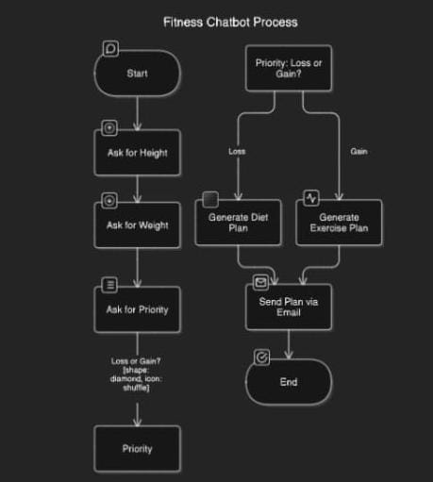

**ARCHITECTURE DIAGRAM**

An architecture diagram is a graphical representation of a set of concepts, that are part of an architecture, including their principles, elements and components. The architecture diagram for this project is

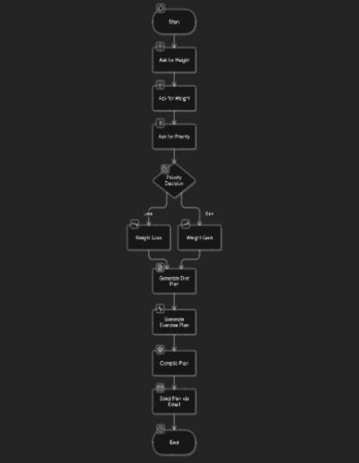

**SEQUENCE DIAGRAM**

A sequence diagram is a type of interaction diagram because it describe and s how in what order a group of objects works together. The sequence diagram for this project

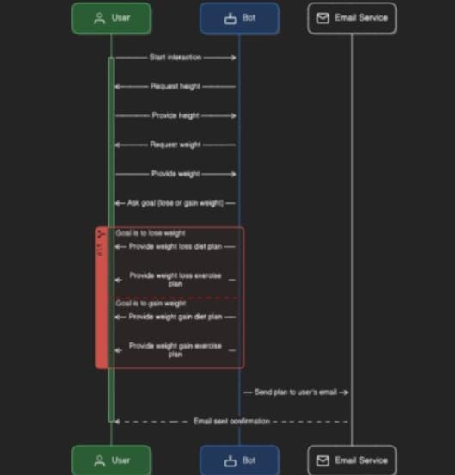

**CHAPTER 4**

**PROJECT DESCRIPTION**

**"The Fitness Guide Chat Bot"** is an advanced Robotic Process Automation (RPA) project developed to simplify the process of creating personalized fitness plans. Utilizing UiPath, this bot automates the collection of user inputs, generates tailored diet and exercise plans, and ensures seamless delivery via email. This intelligent bot enhances user engagement by providing customized wellness guidance efficiently.

**MODULES:**

**INPUT HANDLING AND INITIALIZATION:**

**User Data Collection:**

* Prompt users to input personal details such as height, weight, and fitness goal (weight loss or gain).

**Data Storage:**

* Collect and securely store user input for further processing.

**CONTENT GENERATION:**

**Personalized Plan Creation:**

* Utilize AI-based algorithms to generate a customized diet and exercise plan tailored to the user’s data (height, weight, and goal).
* Employ content generation tools to create a comprehensive and user-specific wellness plan.

**OUTPUT HANDLING:**

**Email Preparation:**

* Format the generated diet and exercise plan for easy readability and access.
* Prepare the content for email distribution using SMTP.

**Plan Delivery:**

* Send the personalized plan to the user’s email address provided during the initial input collection.

**RESULT MANAGEMENT:**

**User Confirmation:**

* Notify the user that the plan has been successfully generated and sent to their email.
* Provide real-time feedback during the process to keep the user informed.

**COMPLETION AND REPORTING:**

**Completion Message:**

* Conclude the process with a message confirming the successful delivery of the fitness plan.
* Ensure that the user receives all necessary details for following their tailored diet and exercise regimen.

# CHAPTER 5

# OUTPUT SCREENSHOTS



The bot prompts the user to enter their height, forming the first step in gathering personal data for creating a customized fitness plan.



The user is prompted to input their current weight, which helps the bot in calculating and tailoring the diet and exercise plan.



The bot asks the user to select their fitness goal, such as weight loss, to personalize the upcoming fitness recommendations.

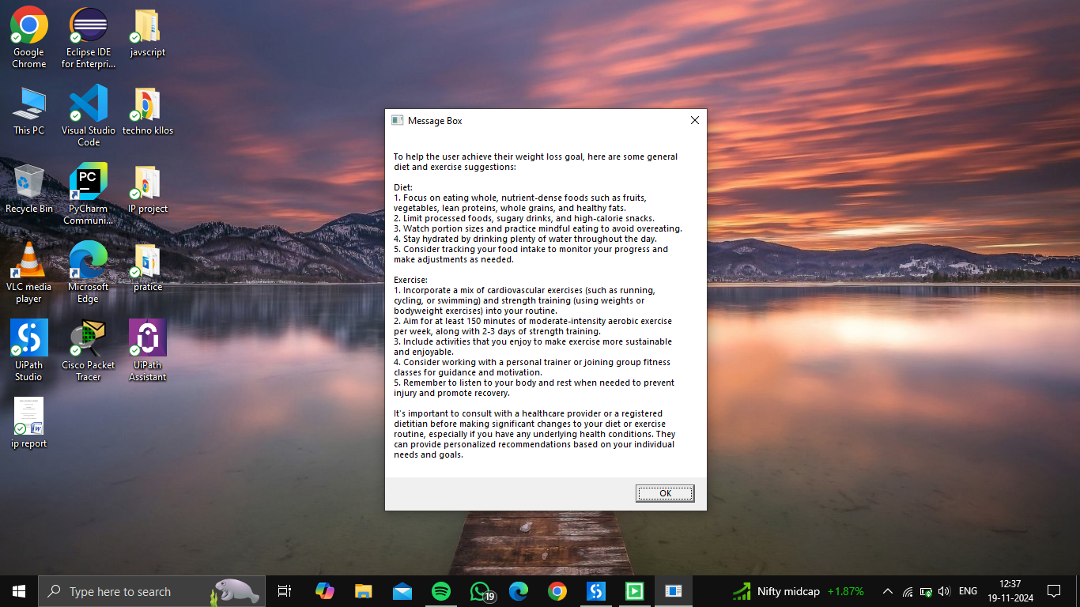

The bot generates a detailed diet and exercise plan specifically designed for weight loss, as per the user’s input data



The bot displays the user’s selection of a weight gain goal, initiating the generation of a plan suitable for their target.

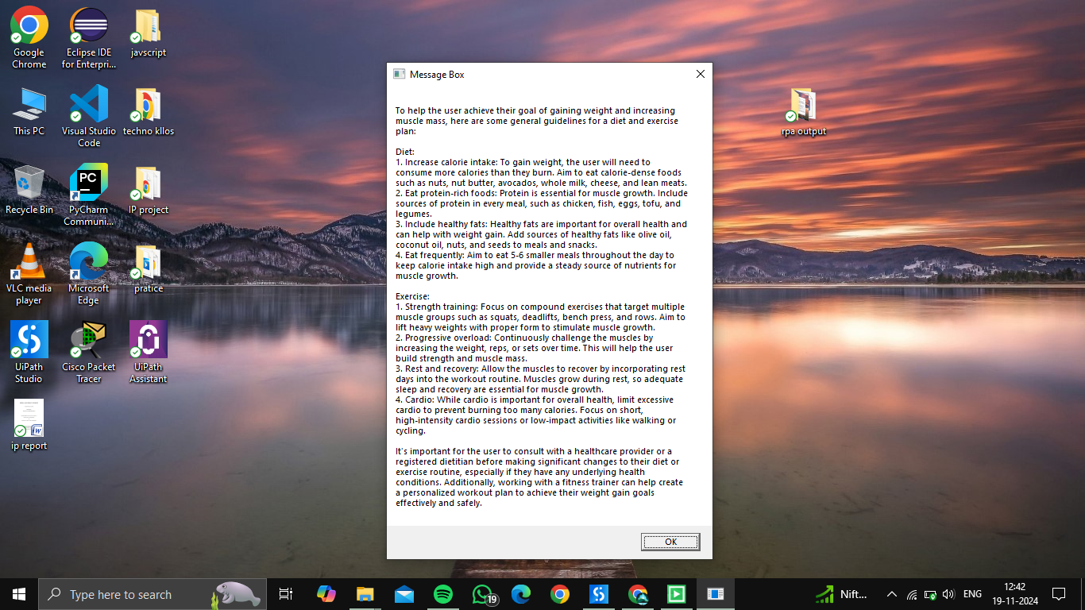

A customized diet and exercise chart is created by the bot to support the user's goal of weight gain.

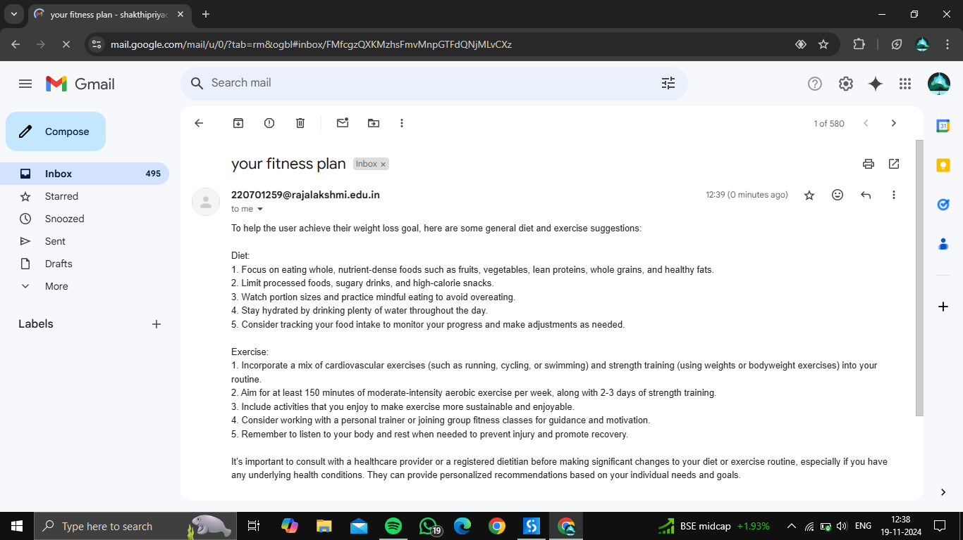

The personalized weight loss plan is sent to the user’s email, providing an accessible and easy-to-follow diet and exercise routine

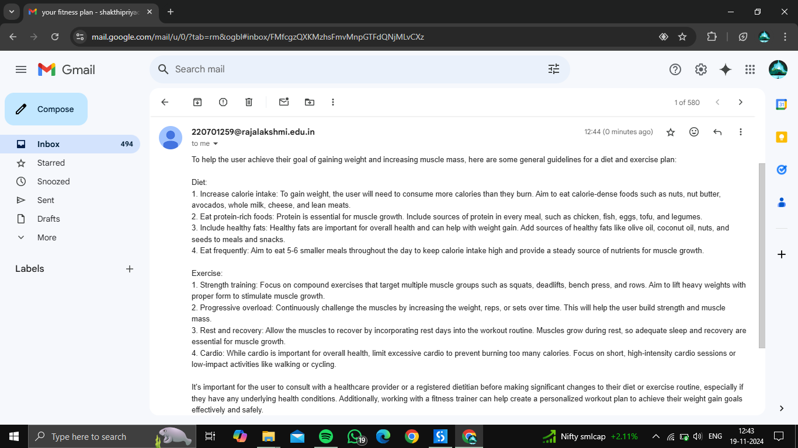

The tailored weight gain plan is sent to the user’s email, ensuring they have a clear and personalized guide to follow.

CHAPTER6

CONCLUSION

"The Fitness Guide Chat Bot" marks a significant step forward in personal wellness management by harnessing the capabilities of UiPath's Robotic Process Automation (RPA). This innovative solution simplifies the process of creating personalized diet and exercise plans, ensuring that users receive accurate and tailored fitness guidance efficiently. The project’s ability to provide real-time updates and deliver customized plans via email enhances user engagement, presenting a streamlined and user-friendly experience. By automating the collection of user data and content generation, the bot allows users to access expert wellness advice without manual effort, empowering them to pursue their fitness goals effectively. While the system offers comprehensive and data-driven fitness plans, its scope may be limited by the need for human intervention in cases requiring nuanced dietary or fitness recommendations. Regular updates to the AI algorithms and exercise databases will be essential to keep up with advancements in health and nutrition knowledge.

CHAPTER 7

# APENDIX

# PROCESS WORKFLOW

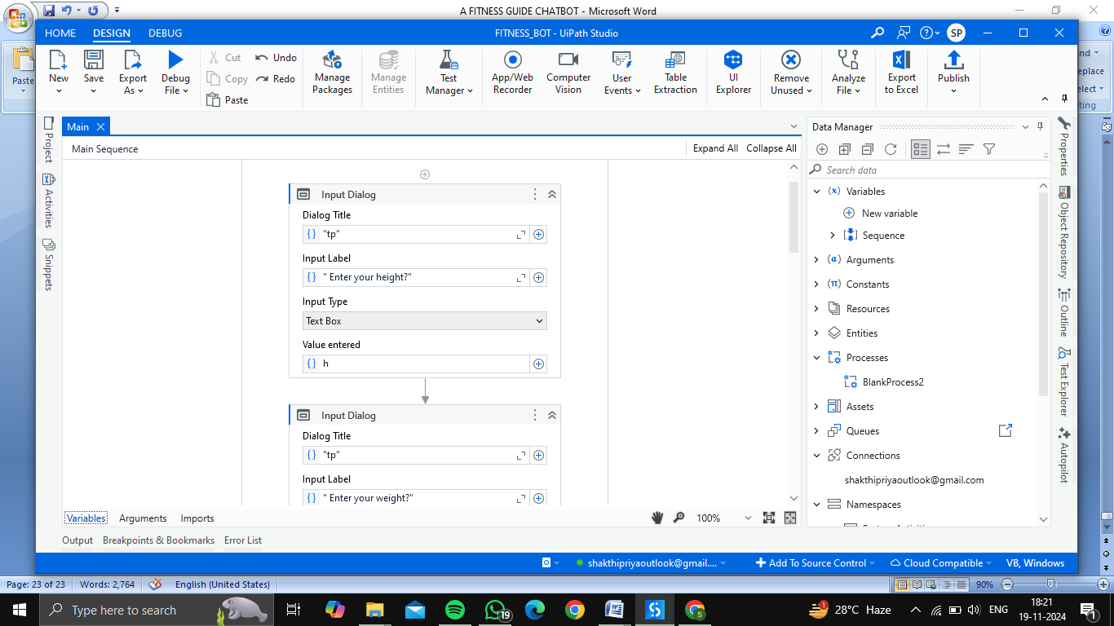

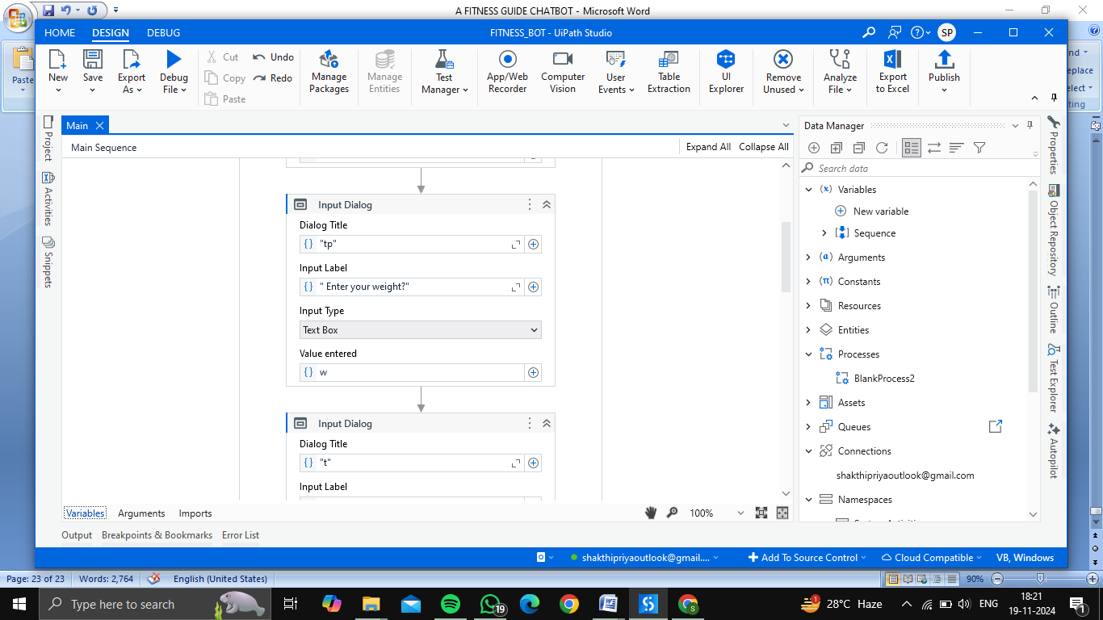

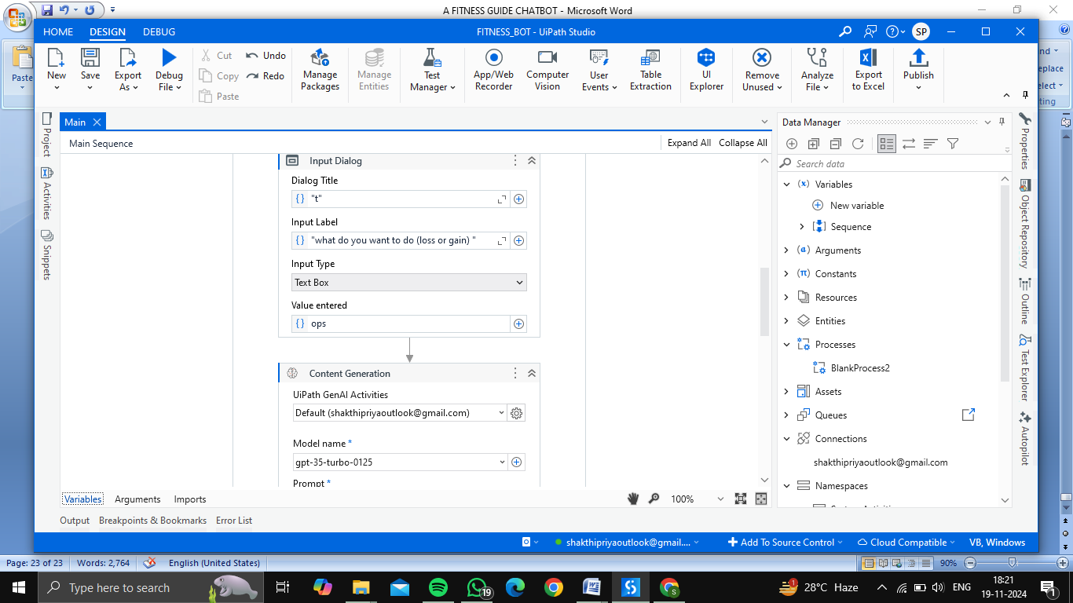

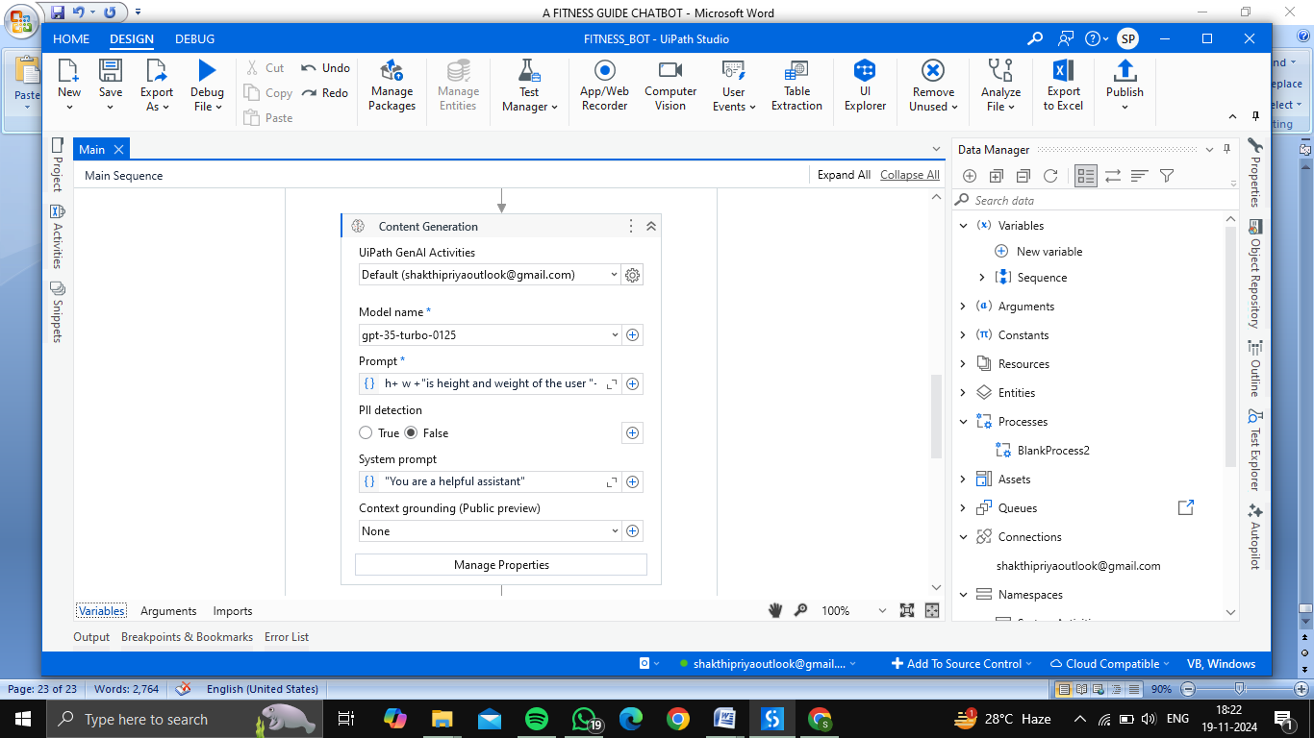

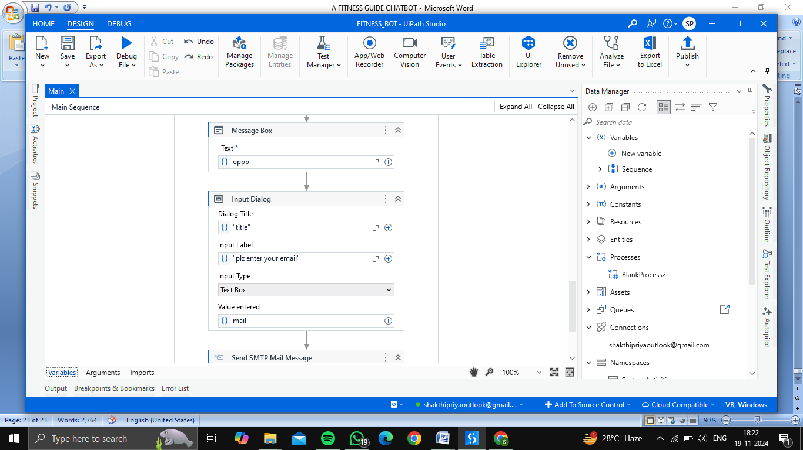

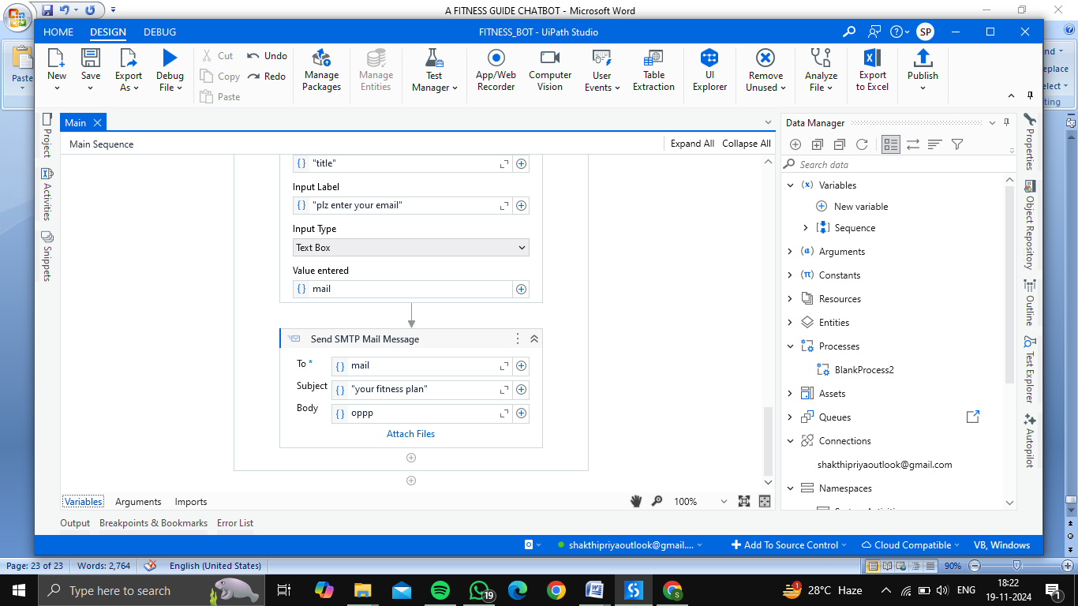

**REFERNCES**

[1] Singh, R., & Sharma, A. (2021). **Robotic Process Automation in Personal Health Management: Opportunities and Challenges**. Journal of Health Informatics Research, 13(2), 150-162. doi: 10.1007/s40313-021-00213-4.

[2] Patel, M., & Gupta, L. (2020). **Integrating RPA in Personal Fitness Tracking Systems**. International Journal of Innovative Health Technologies, 9(3), 678-683. doi: 10.35940/ijih.K2390.093022.

[3] Williams, K. (2022). **Diet Personalization Using AI-Based Data Processing**. Journal of Nutritional AI Studies, 7(1), 102-110. doi: 10.1029/nas.2022.10402.

[4] Jones, D. & Martinez, P. (2023). **Automated Email Integration for Personalized Health Services Using RPA**. Journal of Automated Systems and Healthcare, 15(4), 278-284. doi: 10.1109/JASH2023.1094392.

[5] Tan, H., & Lee, S. (2019). **Machine Learning and AI Approaches for Tailoring Exercise Plans**. Advances in Computational Health Engineering, 5(6), 423-431. doi: 10.1145/3410178.

[6] Murphy, J., & Ladd, T. (2021). **Challenges in Developing Automated Health and Diet Bots: A Case Study**. Proceedings of the 2021 Conference on Digital Health and Wellness, 112-119. doi: 10.1007/40979-021-00310-8.